DRY Principle
In software engineering , don’t repeat yourself (DRY) is a principle of software development aimed at reducing repetition of software patterns.
In the earlier lecture, we were making static content into variables so that there can be single source of info.
We do repeat multiple times various terraform resources for multiple projects.
Sample EC2 Resource:
Resource “aws_instance” “myweb” {
Ami = “ami-xxxx”
Instance_type = “t2.micro”
Security_groups = [“default”]
}
Source module “source”

Resource “aws_instance” “myweb” {
Ami = “ami-xxxx”
Instance_type = “t2.micro”
Security_groups = [“default”]
}
Here in the module there won’t be much code present in the tf file. All the code will be present in source block. So we will use the module for multiple projects with less code for both the projects.
Implementing EC2 module with TF
Now we will creating an ec2 instance by using module. For that first we will create folders like this for easy identification. But coming to organization’s project level the folder structure may change.
Now I’ll be creating two folders.
- Modules
- Projects
Under modules folder we will create a folder with the name of ec2. Inside the ec2 folder we will create a ec2.tf file. In this file we will be adding the script which it will help to create a resource like type, size & name etc.
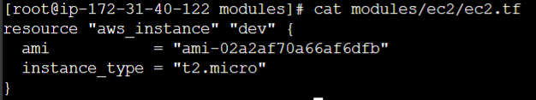
Now we need to call this script to create ec2. For that we are going to project “a” which is inside the projects folder. We will create a file with the name of creation_ec2.tf.
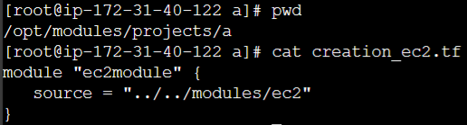
Here ec2module is naming convention and ../../module/ec2 is the path where ec2.tf is there.
And we need to provide the providers also. We will provide the providers also in the same folder of project a but in different file like this.
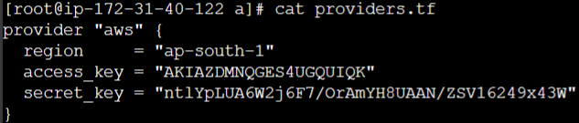
Note: The main advantage of using module is that, We will reduce the code size in a file and we can easily call them in different projects. If we want to create a security group we will just call the module with the path where security group script is there. It’s not required write the whole script completely.
Challenges with modules
One common need to infra management is to build environments like staging, production with similar setup but keeping environment variables different.
Staging
Instance_type=t2.micro

Instance_type=m4.large
Prod

Challenges: Mainly the challenge will be if you are calling the code in the source box for other environments where it required a different instance type in a resource. Since it’s hard coded we can’t call a different type. If we want, we need to hard code it again.
Eg: If you add a line in project “a” code instance_type = “t2.large”, it will show the argument is unexpected.
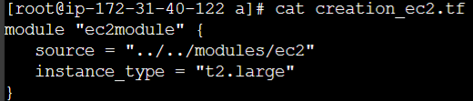
So, If you have hard coded the things within your module, then you will not be able to override it from destination file. To overcome it we will create a variable file and will define the variables. This file will be created inside modules folder and inside ec2.
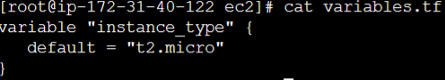
Now ec2.tf will look like this
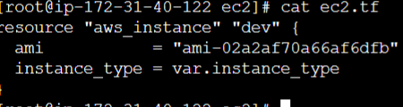
Since we defined the “variable type” in var file the destination filder will overwrite the default value in variable file.
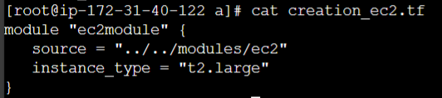
In above script, actually it will create t2.large as specified explicitly instead of default value t2.micro which defined in variable file. If you want to take the default value we need to remove the variable in destination file.
Using locals with modules
If you use variables with modules, If any user made changes in the script explicitly it will be overwritten by default variable.
Variable file
Defining variable in source
So If any user make changes in the creation_ec2.tf file explicitly it will overwrite the variable file’s default value. So to overcome that we will use “local”. So that user can’t modify explicitly.
- Instead of variables, you can make use of locals to assign the values.
- You can centralize these using variables but users will be able to override it.
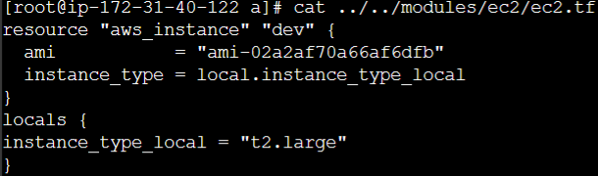
The above script will help to specify the locals in terraform script.
Note :- If it’s user’s value, let’s say random port numbers like 8080, 8081 and 85 etc. can be specified without double quotation in locals.
Eg:
locals {
instance_type_local = “t2.large”
app_port = 8085
}
Referencing Module Outputs
Revising output values:
Output values make info about your infra available on the command line, and can expose info for other TF config to use.
Accessing child module outputs:
In a parent module, output of child modules are available in expression as module.<MODULE NAME>.<OUTPUT NAME>
To understand this let’s see the below scenario. In below scenario we are going to ste the t2.micro’s instance id as t3.micro’s name.
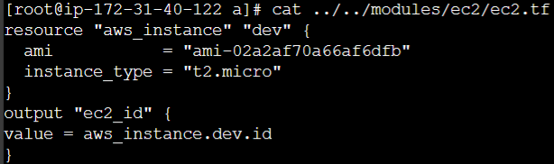
Here In the module file I’m defining the output variable. The Variable will be “ec2-id” and the value will be “aws_instance.dev.id”. here you are calling the t2.micro’s instance id.
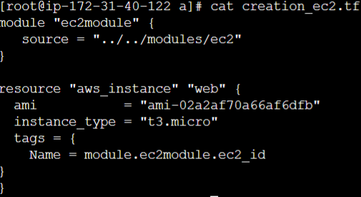
From above code, In the user script we are going to create another ec2 instnace with t3.micro. For that we are going to config under “tags” for variable “Name” we are going to define the value “module.ec2module.ec2_id”.
Here module and ec2module is from user defined scripts first 2 words and ec2_id is variable where we defined in module script from 1st SS.
Note: The above script will not show the value while executing. To show that we need to define like this.
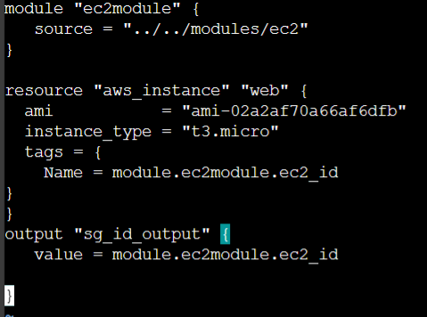
Terraform Registry
The terraform registry is a repo of modules written by the TF community.The registry can help you get started with TF more quickly.
One of the main advantage of TF registry is that within TF registry, you can find verified modules are maintained by various third party vendors. These modules are available for various resource like AWS VPC, RDS, ELB and others.
Using registry module in TF:
To use TF Regisrty module within the code, we can make use of the ‘source’ argument that contains the module path.
Below code references to the EC2 Instance module within TF registry
module “ec2-instance” {
source = “terraform-aws-module/ec2-instance/aws”
version = “2.13.0”
}
For clear understanding watch the video again. Because it’s hard to explain it here.
Requirement for publishing modules
Anyone can publish and share modules on the TF registry.
Published modules support versioning, automatically generate documentation, allow browsing version histories, show examples and READMEs and more.

Requirement | Description
Github | The module must be on github and must be a public repo. This is only a requirement for the public registry.
Named | Module repositories must use this three-part name format terraform-<PROVIDER>-<NAME>
Repo description | The Github repository description is used to populate the short description of the module
Standard module structure | The module must adhere to the standard module structure
x.y.z tags for releases | The registry uses tags to identify module versions. Release tage names must be a sematic version, which can optically be prefixed with a v. For example, v1.0.4 and 0.9.2

For clear understanding watch the video again. Because it’s hard to explain it here.
Terraform Workspace
Workspace is a same similar kind of windows which has implemented in TF. In windows let’s say if we have created 2 spaces for 2 users are single person, the first one is having entertainment related thing and second one is related to study.
TF allows us to have multiple workspaces, with each of the workspace we can have different set of environment variables associated.
Staging
Production
Instance_type = t2.micro
Instance_type = m4.large

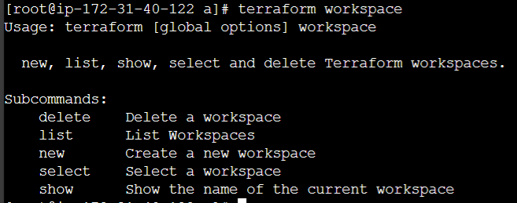
To show the current workspace
To show list of TF workspace
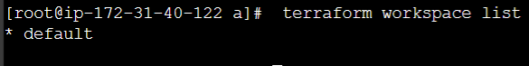
To switch from one workspace to another we use
terraform workspace select dev
Even though we don’t have “dev” workspace I have shown as an example.
Implementing TF workspace
Let’s assume a scenario, If it’s default – t2.nano, dev – t2.micro, prd(prod) – t2.large. we need create the workspace as per above requirement.
To create new workspace we need to use.
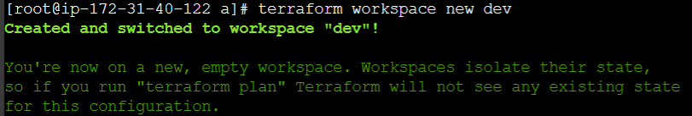
Here we have totally 3 workspaces for that we need write the code.
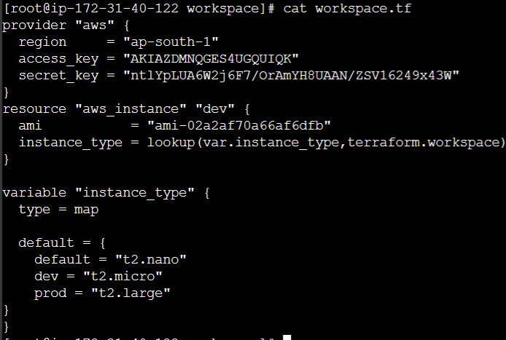
In above script we have defined variables for workspaces and we have used lookup function to search as per the requirement. Here var.instanc_type we got it from variable and terraform.workspace is the workspace which you are in.
Now If you switch from default to dev by using “terraform workspace select dev” command it will switch to dev workspace. Now If you run “terraform apply” It will select the t2.micro server and create it. Same for prod also.
Note: If you run the ls command you will see the “terraform.tfstate.d” folder. Inside that you will see dev and prod folders. Remember that in workspace, TF mainatains the tf state files separately for each workspace. For “default” workspace it won’t present inside “terraform.tfstate.d” the tf state files will be present outside of it.

